Project Details

Name : Yash Vijay Date
Company: Somayu Infotech
Mentor:

A. Website Using HTML,CSS And JS
Url: https://amazon-e-shop.vercel.app

B. Power Bi Dashboards
HealthCare Hospital Dashboard

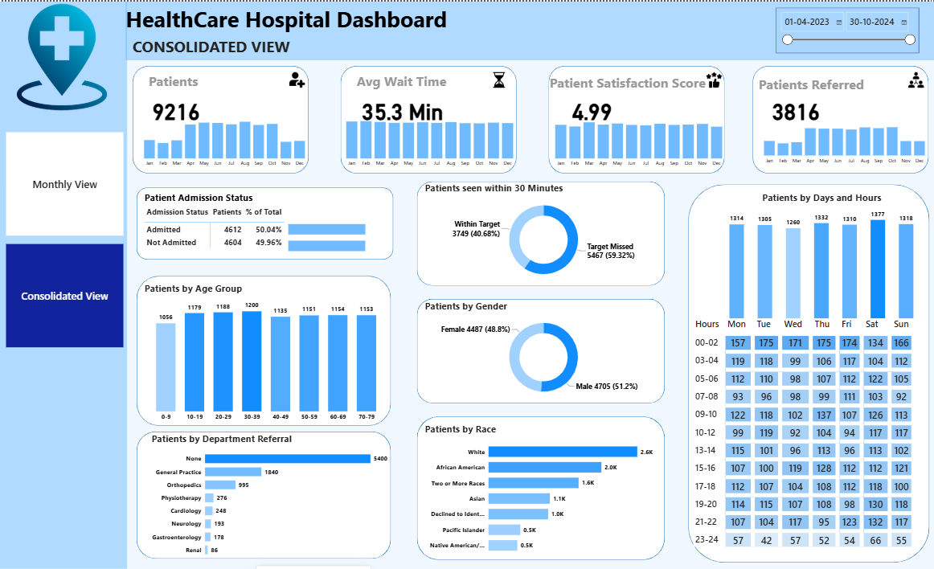
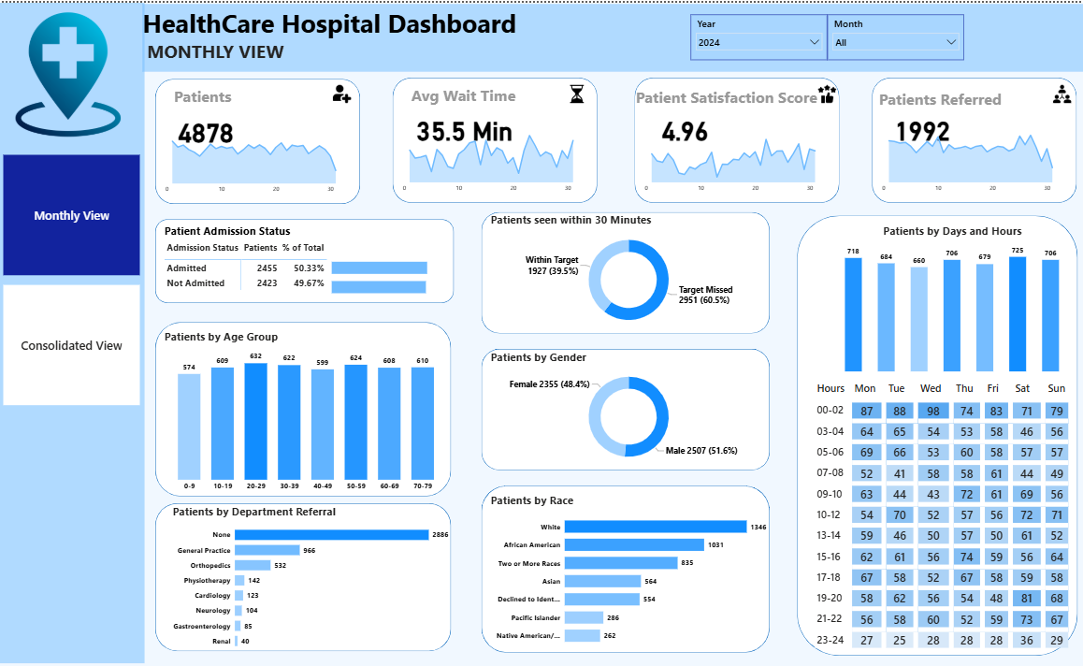

C. Full-Stack Project :– College Sahayak

1.Login
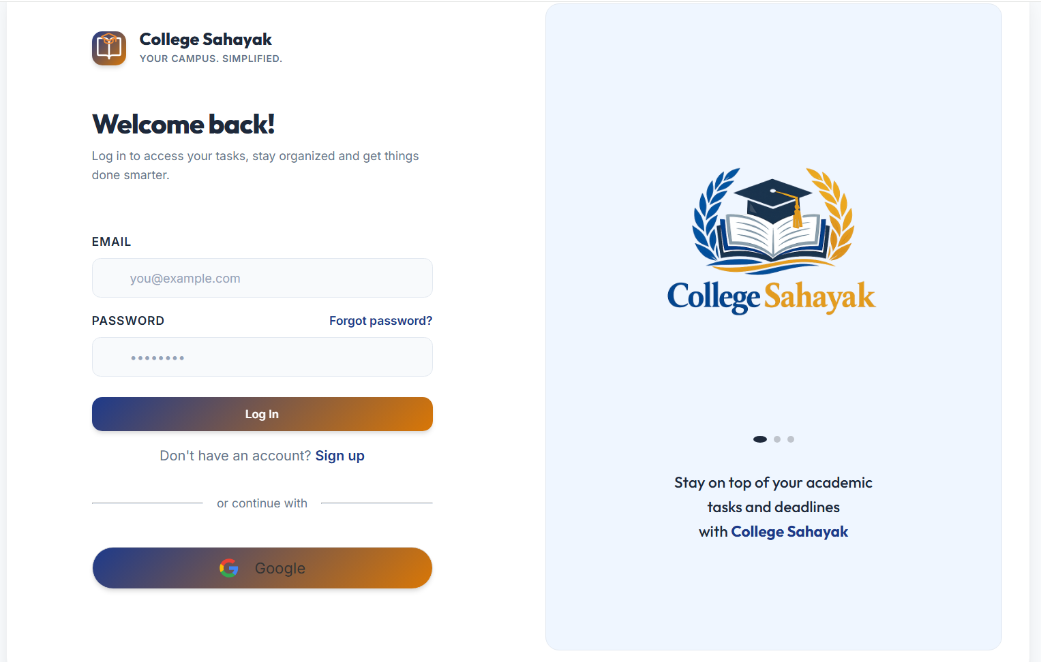
2. Register
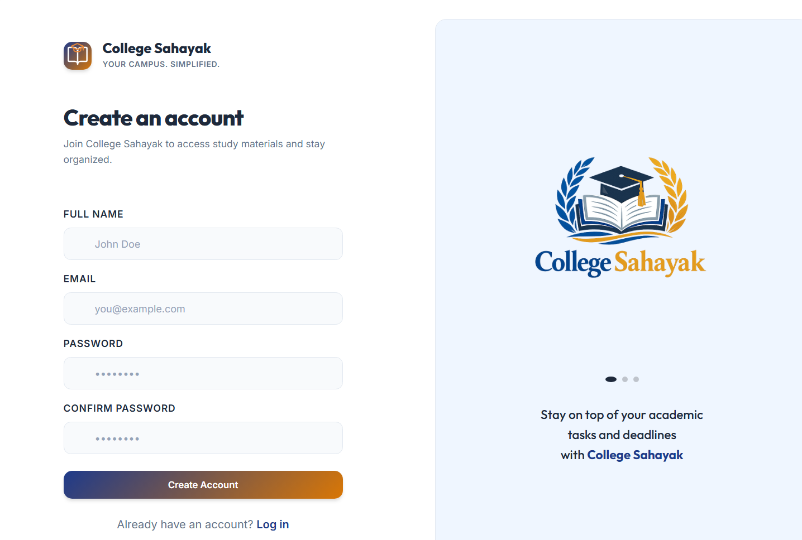

3. Home Page
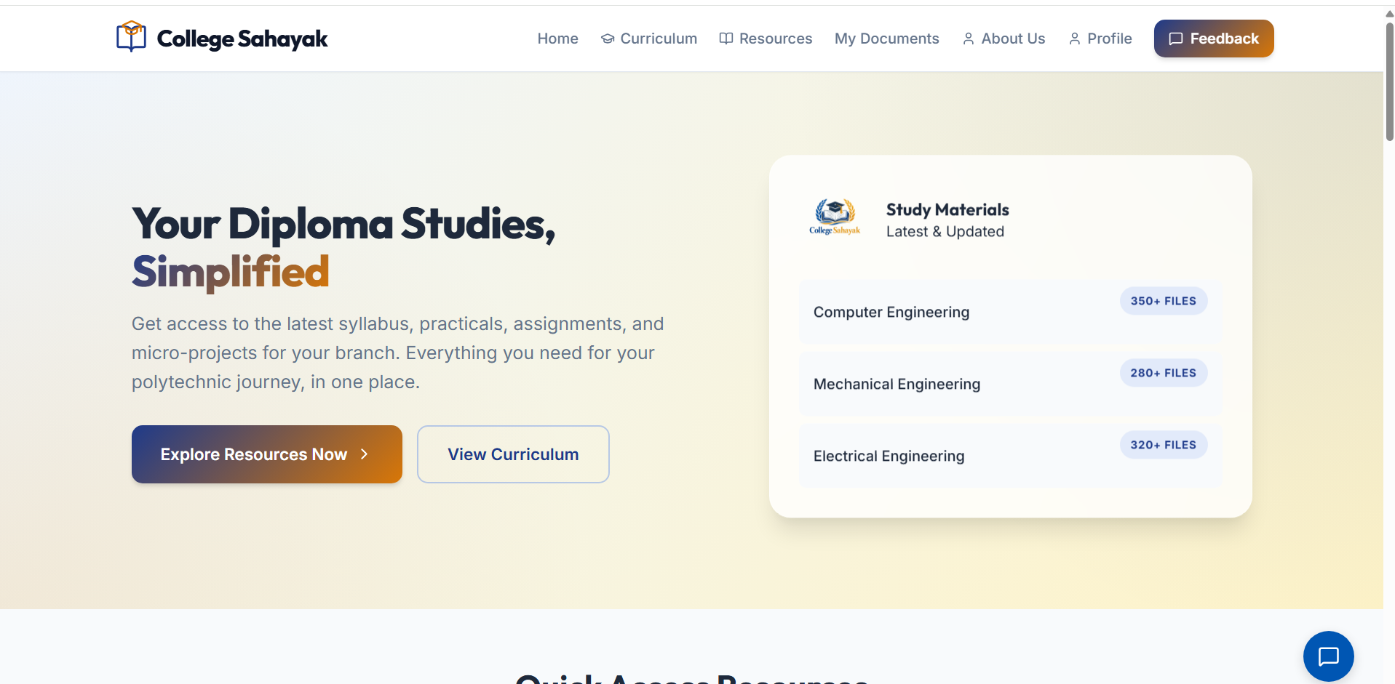

4. Curriculum Page
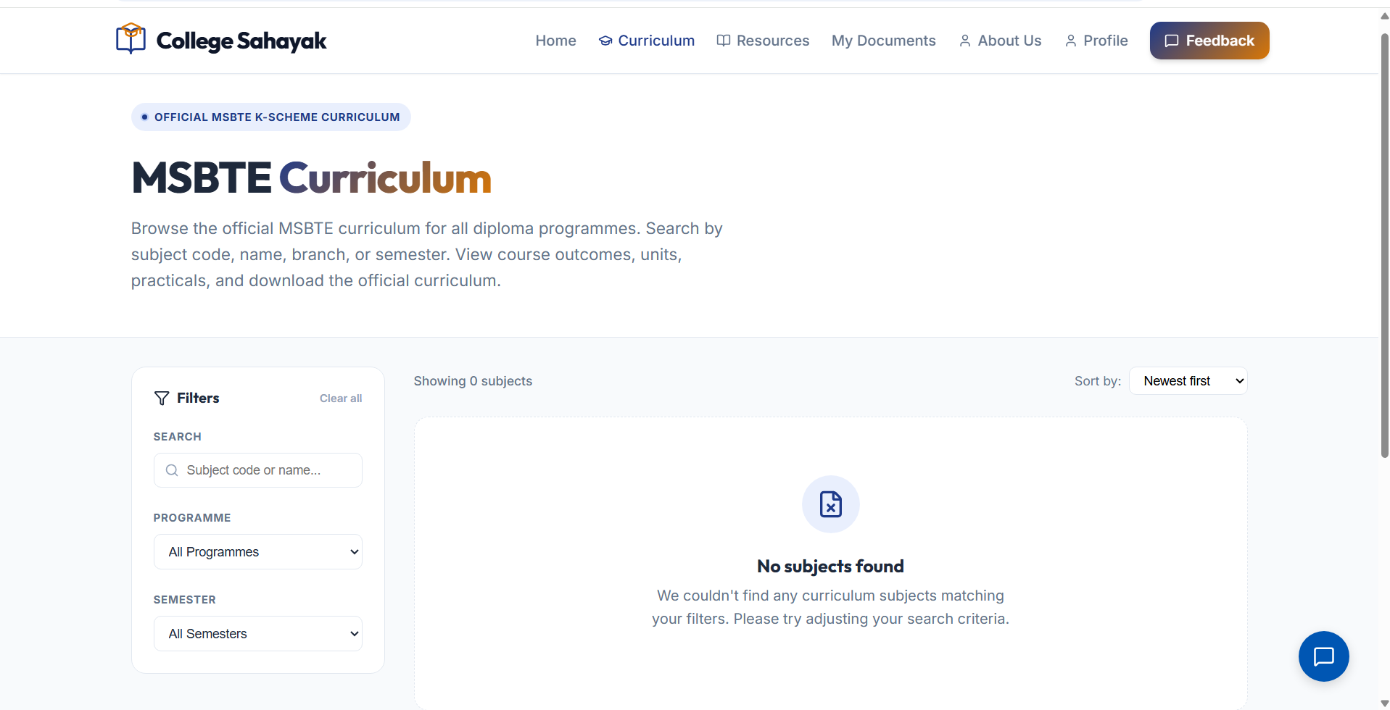
4. Resourses Page
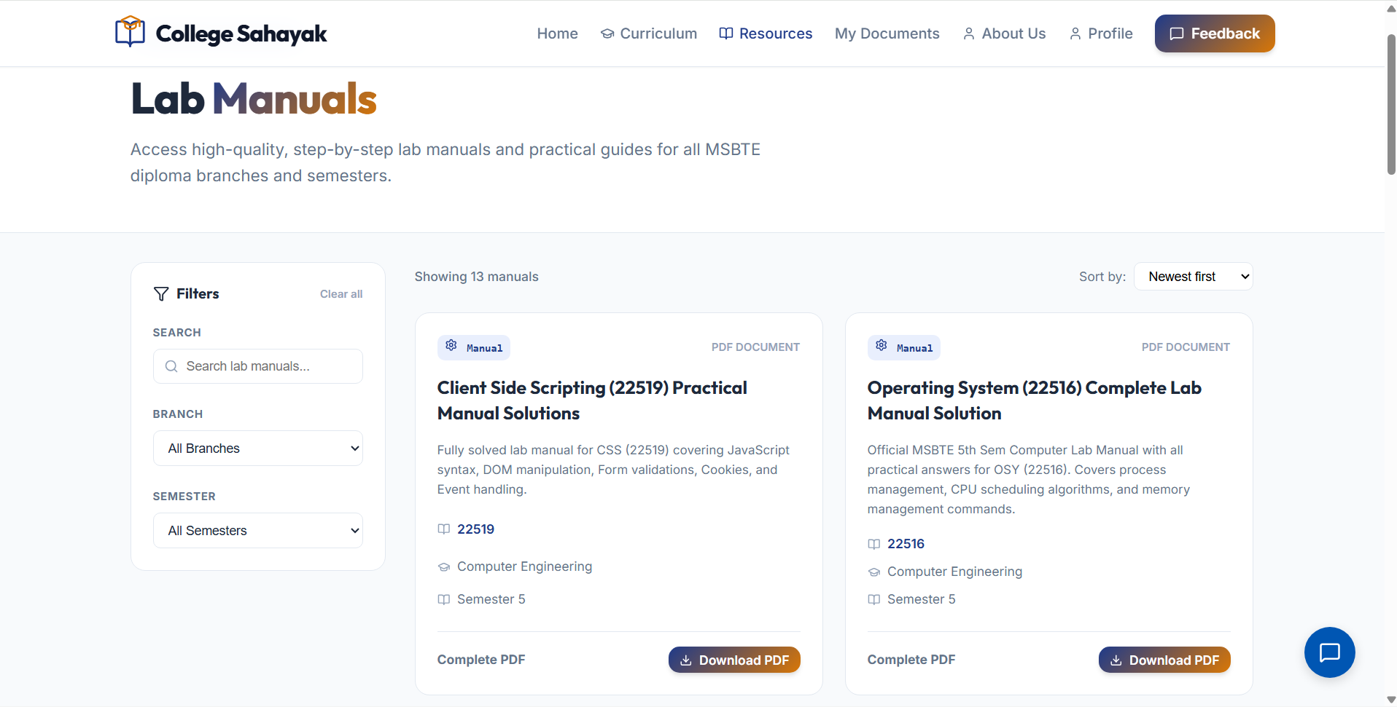

5. My Document Page
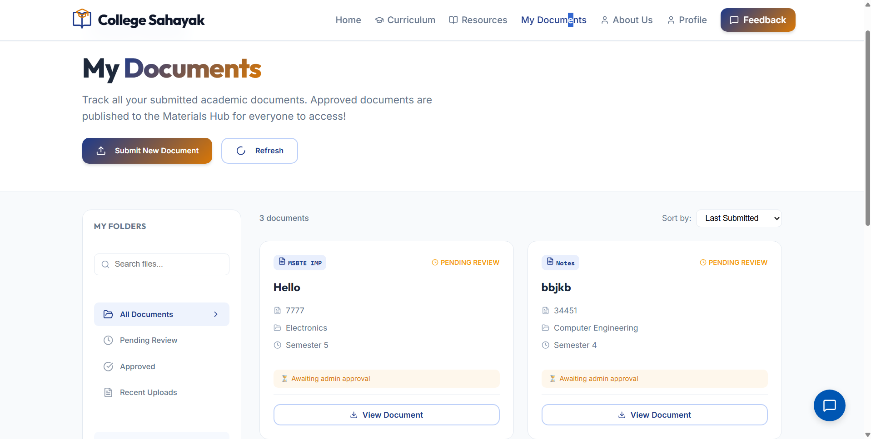
6. Profile Page
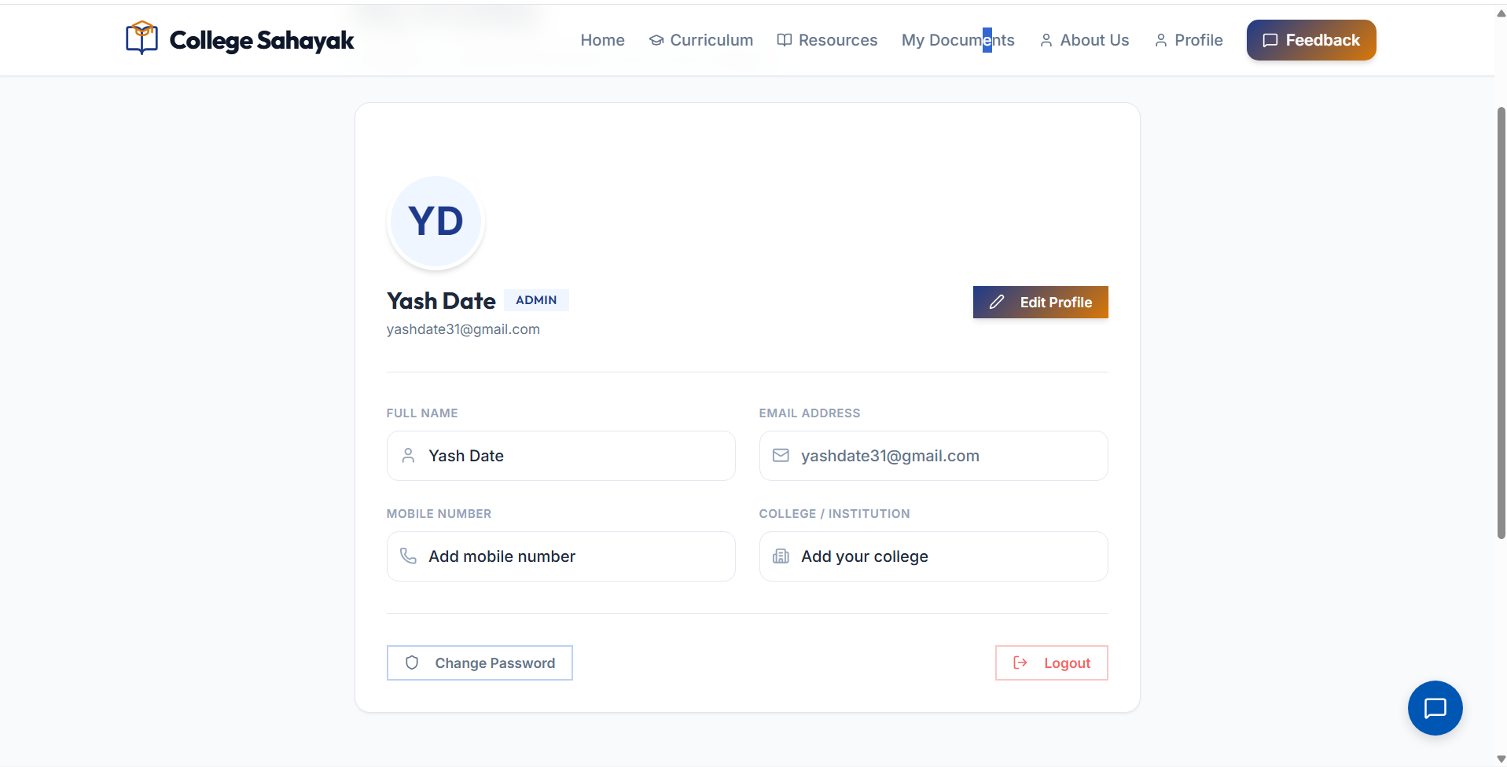

7. Feedback
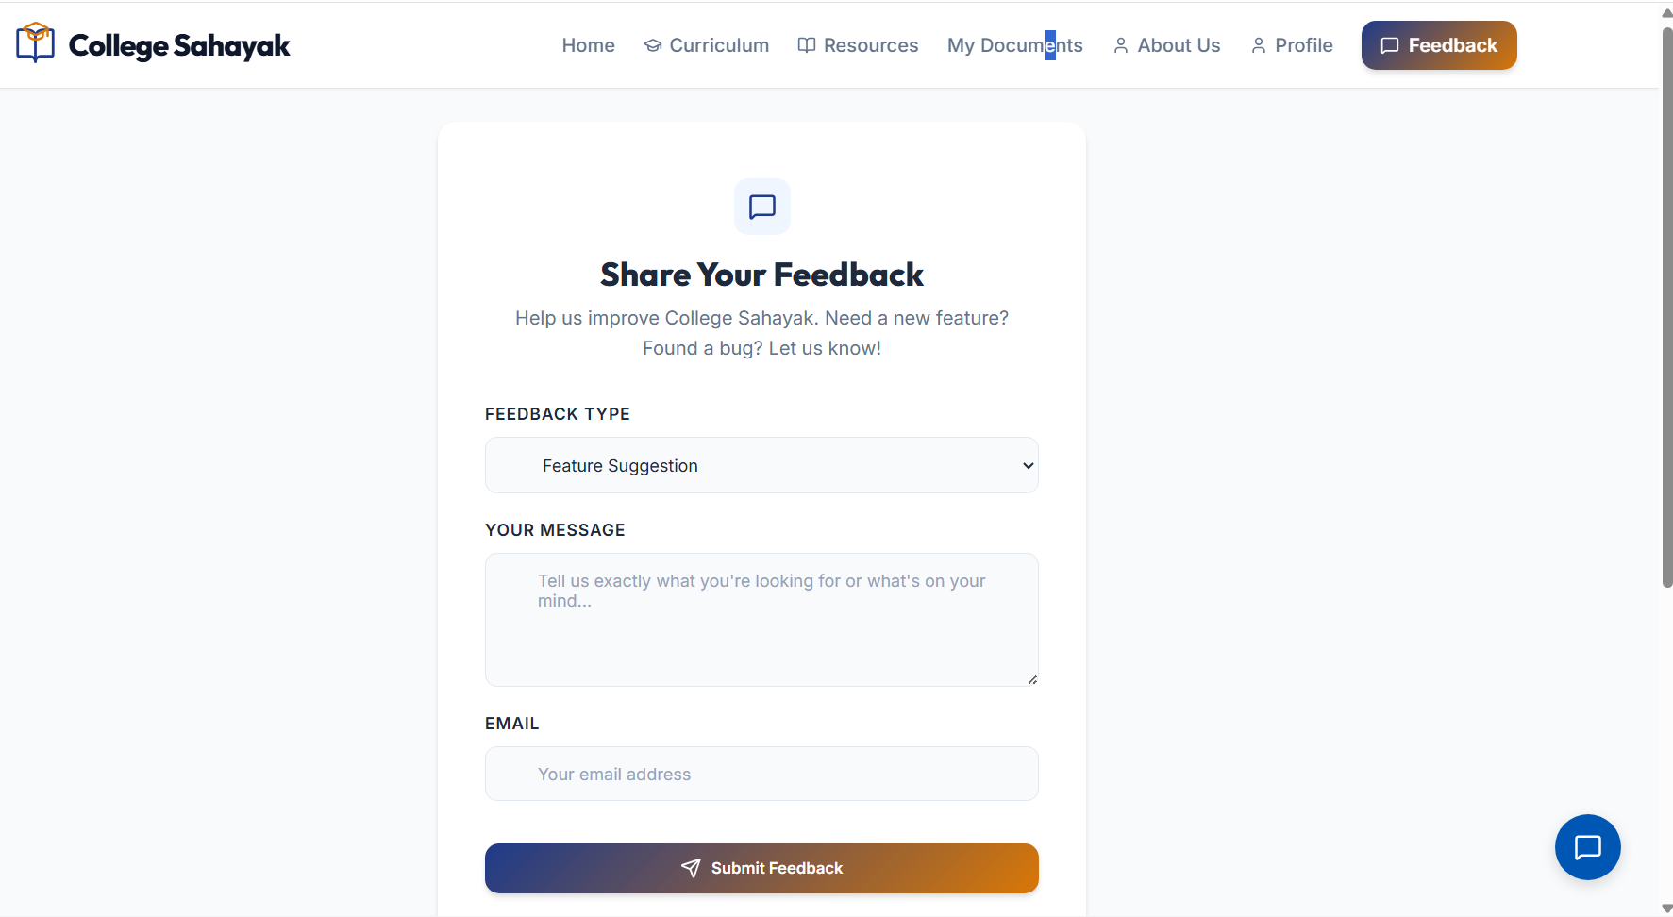

8.Quick Access Resourses
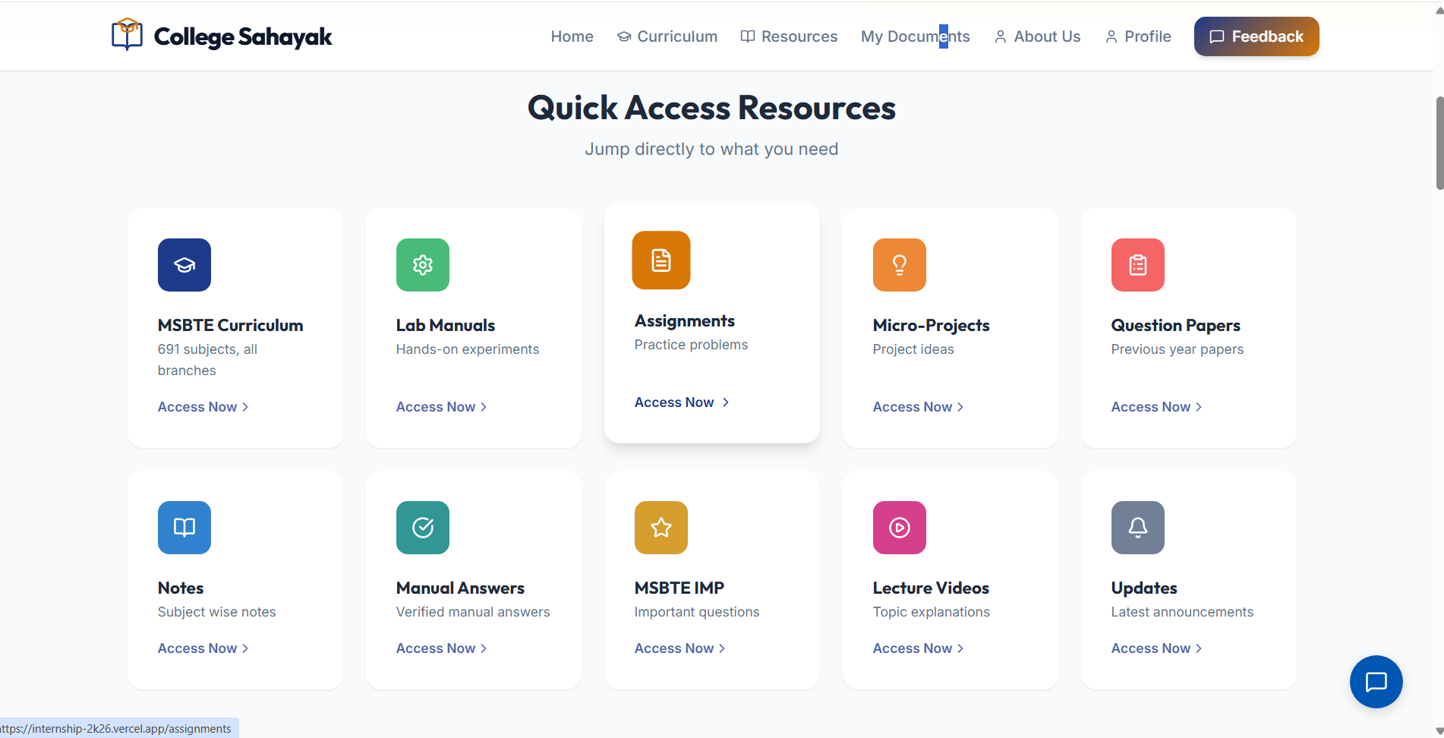

9.Trending Week
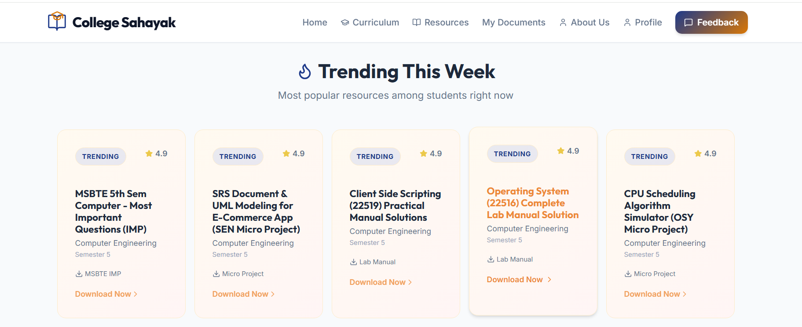

10. Chat Bot for Student Help
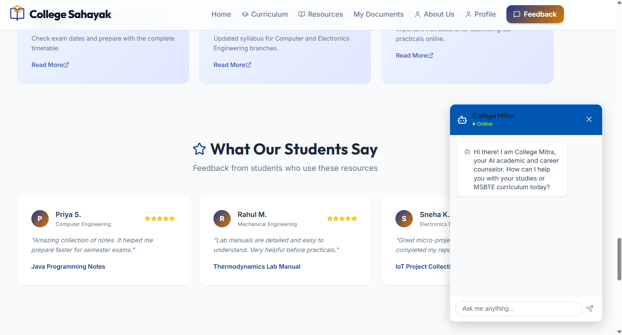

11. Admin Panel
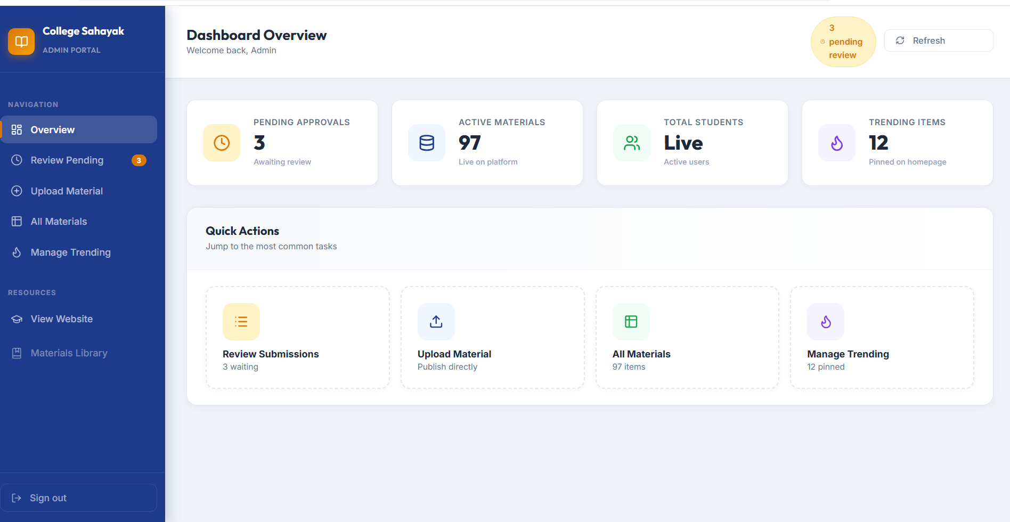
Urls:
Frontend : https://internship-2k26.vercel.app/
Backend : https://college-sahayak.onrender.com/

